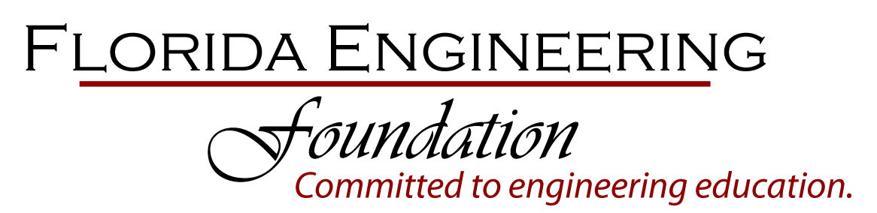

P.O. Box 750
125 South Gadsden Street
Tallahassee, Florida 32302
Phone: (850)224-7121
Email: shawn@FlEngineeringFoundation.org
On the web at: FlEngineeringFoundation.org

FLORIDA ENGINEERING FOUNDATION

BOARD OF TRUSTEES
CONFERENCE CALL MEETING

Wednesday, June 19, 2013
3:30 P.M.
1-866-691-4535; Access 5693562

MEETING AGENDA

- Call to order – 3:30 P.M.

- Roll Call – Establishment of Quorum

- Approve/Amend Agenda

- Status of Previous Meeting Minutes

- Chairman Report

- Budget
  - Treasurer Report John Davis
  - Investment Committee Report Alex Perez

- Annual Meeting Events
  - Dinner Angelina Fairchild
  - Golf Tournament Don Goddeau
  - Silent Auction J W Hunter
  - Other (Raffle, Poker Tournament, etc.)

- Initiatives
  - Web Site Don Goddeau
  - Branding Kim Debosier

- Nominating Committee John Hall

- New Business
  - Project Create Jim Horton/Leslie
Turner
  - FES – FICE Fundraising Consultant - ADS Jim Horton/Glenn
Forrest

- Adjourn – Next Meeting: August 1, 2013 3:30 p.m.
Annual Summer Conference
The Breakers – Palm Beach

